2019 North American Cannabis Summit
Newsletter Copy, Thursday, December 27, 2018

Subject line: Have Lunch with Experts on Cannabis Equity at the 2019 North American Cannabis Summit

Opportunities and Challenges
of Cannabis Equity Programs
Engage in bi-coastal, in-depth discussion at special session with Shaleen Title and Cat Packer
Summit participants will have an unparalleled opportunity to talk with experts on cannabis equity from both coasts.
Shaleen Title, commissioner with the Massachusetts Cannabis Control Commission, and Cat Packer, executive director of the City of Los Angeles’ Department of Cannabis Regulation, will facilitate a lunch & learn session on implementing equity programs at the state and city level.
Drawing on these experts’ perspectives and experience, 2019 Summit participants will leave with concrete ideas from both coasts about how they can work to advance equity programs within their own spheres of influence.
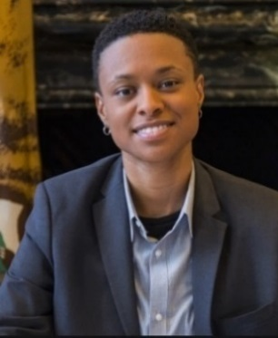
Shaleen Title was jointly appointed last year by the Massachusetts governor, treasurer, and attorney general to serve in the social justice seat of the Cannabis Control Commission, the independent state agency charged with regulating the legal marijuana industry. | Cat Packer is the first executive director of the City of Los Angeles’ Department of Cannabis Regulation. In this role, she leads the licensing and regulation of commercial cannabis activity, in addition to implementing related policies and programs.
Go to http://northamericancannabissummit.org/speakers-2/ for more information about our speakers!
Only 5 Days Left for Discounted Registration and Lodging!
The new year is speeding toward us, as is the end of the discounts on registration and lodging—save $100 on both if you book before January 1, 2019! Don’t miss your chance for the tremendous formal and informal networking that happens when you stay at the center of activity.

Register now at http://northamericancannabissummit.org/register/
Book your room now at http://northamericancannabissummit.org/hotel/
For more information, contact:
2019 North American Cannabis Summit
720-684-6428
nacs@ahpnet.com
NorthAmericanCannabisSummit.org
#NACannabisConvo

If you no longer wish to receive these emails, please reply to this message with "Unsubscribe" in the subject line or simply click the following link: Unsubscribe.
Advocates for Human Potential, Inc.
490-B Boston Post Road
Sudbury, MA 01776
USA
Read the VerticalResponse marketing policy.

